Work Flow / Flow Chart

STEP #2

STEP #1

PURPOSE

START

STEP #3

STEP #4

FINISH

EXAMPLE

STEP #5

Here is an example of a flow chart for a process work flow:

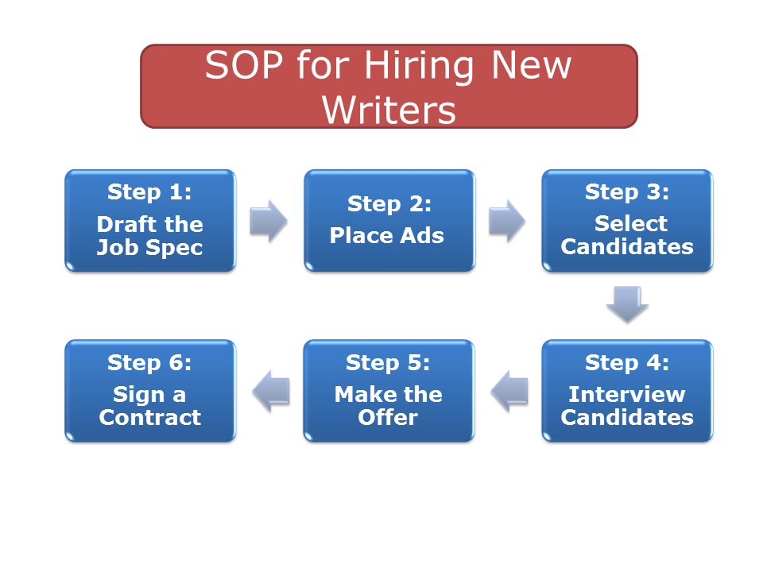

LOGO 1 Page SOP Template [Your Title]
Created by:
Version #, MM/DD/YY
Approved by:
Date of approval:

SOP Name: Enter SOP Name

Purpose: Enter high level overview of the purpose

Scope: Enter high level description of the scope of the procedure

Definitions:
Sample An example showing the correct use
SOP Standard Operating Procedure

Description: 1 Page SOP Template

Procedure:

Step #1:
- Instructions
- Instructions

Step #2:
- Instructions
- Instructions

Step #3:
- Instructions
- Instructions

Attachments:

Step-by-Step Style SOP [Your Title]

Overview
Insert the title of your Standard Operating Procedures document. Use this template as a guide for creating your own. Depending on the SOP you are creating, you may want to add more categories and details. However, for basic SOPs you can probably eliminate some of the sections, or cut them down.

Prepared by
Fill in the name of the original writer of the SOP
Review History
Use the following space to keep track of the review process, people involved and when updates were made.
Date Reviewed | Reviewer | Updates Made? | Approved by
When was the SOP reviewed? | Who reviewed it? | Did he or she make any updates or changes (reviewers should use “track changes” or initial them) | Who made final approval of any changes?
Who this SOP is for
Fill in the roles or titles of people who will be responsible for implementing this SOP. For example, there could be several types of people involved. A process for hiring new graphic designers could require an assistant to place ads, a human resources person to do initial interviews, a senior designer to do final interviews, and another human resources person or assistant to complete paperwork.
Purpose
What is the general purpose of this SOP? For example, an SOP on setting up new client accounts has the purpose of ensuring all relevant information is collected and you don’t have to go back to the client later to request additional details you forgot about.

Description
Describe the process that you will be detailing in the SOP. For example, the SOP for a client intake process can be described as the steps sales people need to complete when signing up a new customer for specific services. The SOP itself could be divided up by type of service the client is purchasing and what steps or information needs to be collected for each.

Process Overview (steps and/or flowchart)
Give an overview of the SOP and the high-level view of what’s going to be covered. This could also be shown as a flowchart or other graphic that users can go back to as a reminder. For example, an overview of the process for hiring new writers could show the steps of Drafting the Job Spec, Placing Ads, Selecting Candidates, Interviewing Candidates, Making the Job Offer, Signing a Contract, etc.

Key Guidelines to Follow
If you have some general guidelines that the person performing the SOP should keep in mind, this is a good place to record them. For example, an SOP for handling customer service complaints could contain guidelines for when the person handling the complaint should bring it to someone higher up in your company.

Potential Problem Areas
Are there any particular areas or warning signs the person performing the SOP should keep an eye out for? For example, if you’ve had an issue with a certain software tool in the past, you could note that here along with what should be done about it. You could also put this section at the end of the SOP and/or include it in the detailed process itself where the problem typically occurs.

Detailed Process
Use this section to outline all the detailed steps of the first SOP being covered. How you write this section will totally depend on the nature of the SOP being covered. Using point form here is fine.
Step 1: High Level Step
- Do this first
- Do this second
- Do this third
  - More steps for number 3
  - Even more details for 3
Step 2: Next Step
- Do this first
- Do this second
- Do this third
  - More steps for number 3
  - Even more details for 3
Step 3: Next Step
- Do this first
- Do this second
- Do this third
  - More steps for number 3
  - Even more details for 3
Attachments:

Checklist Style SOP [Your Title]

Overview
Insert the title of your Standard Operating Procedures document. Use this template as a guide for creating your own. Depending on the SOP you are creating, you may want to add more categories and details. However, for basic SOPs you can probably eliminate some of the sections, or cut them down.

Prepared by
Original writer of the SOP:
Date Reviewed: [When was the SOP reviewed?]
Reviewer: [Who reviewed it?]
Updates Made? [Did he or she make any updates or changes. Reviewers should use track changes or initial them.]
Approved by: [Who made final approval of any changes?]
Who this SOP is for
Fill in the roles or titles of people who will be responsible for implementing this SOP. For example, there could be several types of people involved. A process for hiring new graphic designers could require an assistant to place ads, a human resources person to do initial interviews, a senior designer to do final interviews, and another human resources person or assistant to complete paperwork.
Purpose
What is the general purpose of this SOP? For example, an SOP on setting up new client accounts has the purpose of ensuring all relevant information is collected and you don’t have to go back to the client later to request additional details you forgot about.

Description
Describe the process that you will be detailing in the SOP. For example, the SOP for a client intake process can be described as the steps sales people need to complete when signing up a new customer for specific services. The SOP itself could be divided up by type of service the client is purchasing and what steps or information needs to be collected for each.

Process Overview (steps and/or flowchart)
Give an overview of the SOP and the high-level view of what’s going to be covered. This could also be shown as a flowchart or other graphic that users can go back to as a reminder. For example, an overview of the process for hiring new writers could show the steps of Drafting the Job Spec, Placing Ads, Selecting Candidates, Interviewing Candidates, Making the Job Offer, Signing a Contract, etc.

Key Guidelines to Follow
If you have some general guidelines that the person performing the SOP should keep in mind, this is a good place to record them. For example, an SOP for handling customer service complaints could contain guidelines for when the person handling the complaint should bring it to someone higher up in your company.

Potential Problem Areas
Are there any particular areas or warning signs the person performing the SOP should keep an eye out for? For example, if you’ve had an issue with a certain software tool in the past, you could note that here along with what should be done about it. You could also put this section at the end of the SOP and/or include it in the detailed process itself where the problem typically occurs.

Checklist
Create a checklist that people can use to make sure they’ve covered all the steps in the SOP. The purpose of the checklist is to make it easy for people to follow the SOP without having to read through the longer document each time. Divide up your checklist into sections if there are clear sections to the process, or if there are people who are responsible for specific sections of each.
Attachments: It is important to list any attachments that are applicable to this SOP.

Table Checklist
Complete? | Task

Simple Checklist
Opening instructions or resources
Completed? Task
________________________________________________________________
________________________________________________________________
________________________________________________________________
________________________________________________________________
________________________________________________________________
________________________________________________________________
________________________________________________________________
________________________________________________________________
________________________________________________________________
________________________________________________________________
________________________________________________________________
________________________________________________________________
Authorized by ____________
Closing instructions, notes, resources, etc.

TRAINING CERTIFICATE

STANDARD OPERATING PROCEDURES (SOPs)

___________________________ HAS SUCCESSFULLY COMPLETED
“TRAIN THE TRAINER” TRAINING AND IS CERTIFIED TO TRAIN
[Company] EMPLOYEES ON THE BELOW LISTED “SOP” MODULES

SOP #1
SOP #2
SOP #3
SOP #4
SOP #5
SOP #6
SOP #7
SOP #8

Date: ________________________

________________________ ________________________
TRAINER SIGNATURE DIRECTOR SIGNATURE

